How to Create BugId In JIRA Tool

- Login to Access the JIRA
- BugID to create the JIRA with (+) SCRUM 40 with New Account Module _Account Module.
- 1st Sub task for “Analyzing User Story”

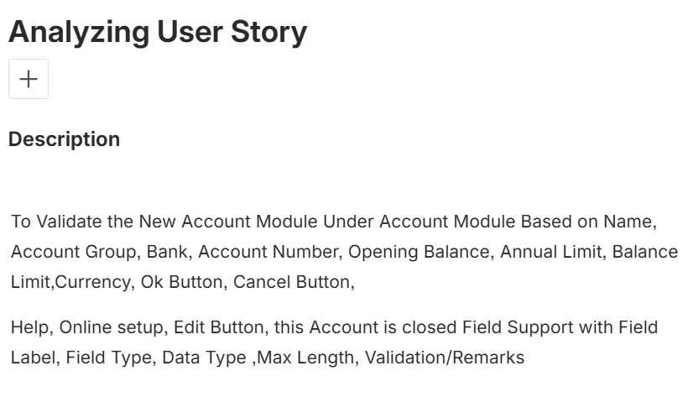For this Fields
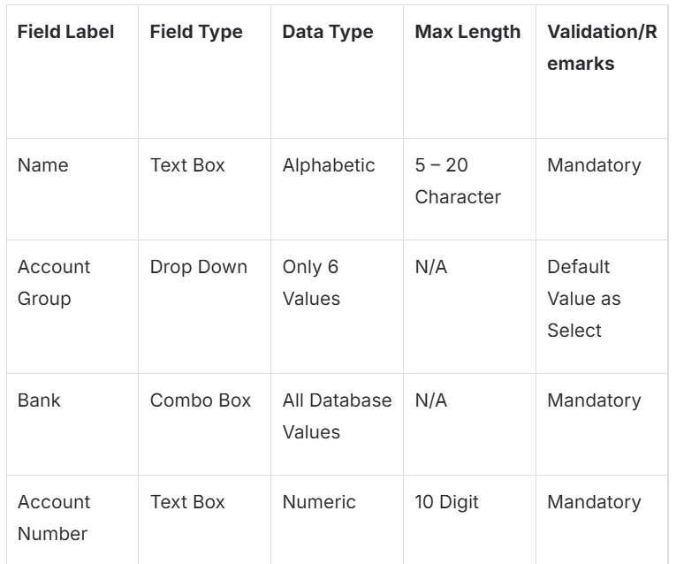
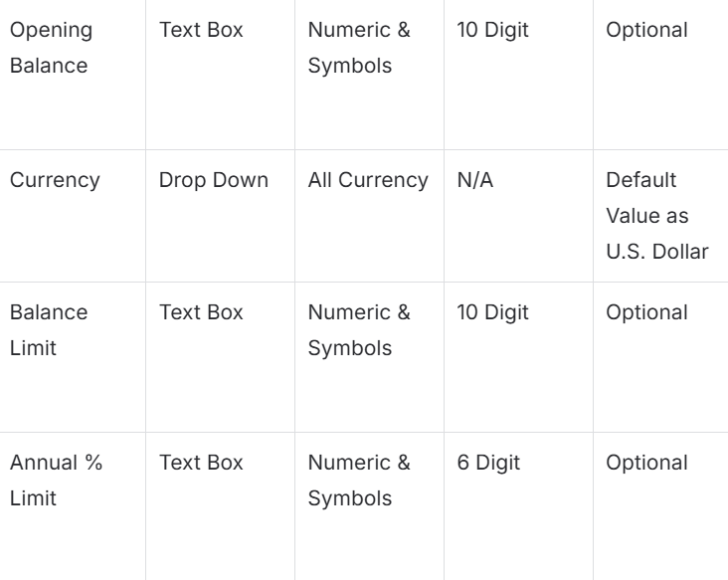
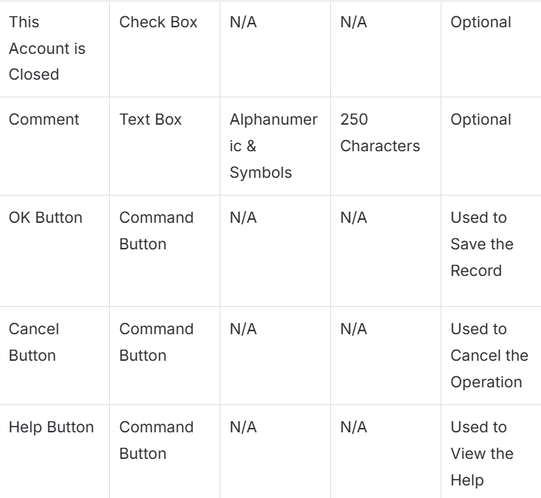

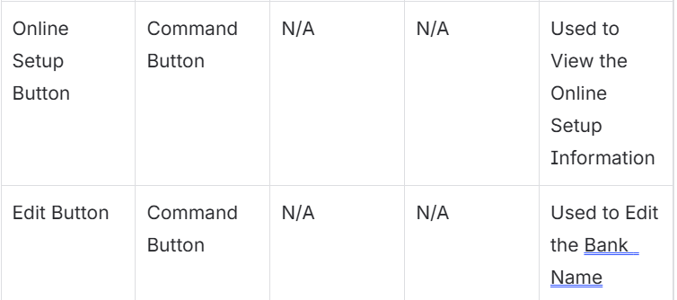

- 2nd Sub Task “Acceptance Criteria”
Test Strategy
User story: New Account module
Purpose:
This is a web based application any valid user account holder can able to login to this application and can access and can able to do manage their account information
It basically consists of 7 Module like Account Module, Portfolio Module, Bank Module, Payee Module, Categories Module, Schedule Module and Reports Module.
Scope:
The Scope of the Project is Finance Management Software is financial software which is used to manage information about the financial transaction between the individual person or the company to the third party . Finance account like deposit or withdraw or transfer details .

NAME FIELD
- To ensure the Name field label
- To ensure the Name field type as Textbox
- To validate the name field data type as Alphabetic
- To validate the name field .
5.To validate the Name field data type with numeric , special chars and symbols
6.To Validate the name field max length less than 5 chars
7.To validate the name field max length greater than 20 chars
8.Submit the new account module application without enter the name field
OPENING BALANCE
- To Ensure the Opening Balance Field Label.
- To Ensure the Opening Balance Field Type as Textbox
- To Validate the Opening Balance Field Data type as Numeric,Symbols.
- To Validate the opening Balance Field Max Length 10 digits
5.To Validate the Opening Balance Field Datatype Alphabets.
6.To Validate the Opening Balance Maximum Length Greater than 10 chars.
7.Submit the new account Modules application without enter the name field.
ACCOUNT NUMBER:

1.To Ensure the Account Number Field label.
2.To ensure the Account Number field Type as Textbox.
3.To Validate the Account Number Field DataType as Numeric.
4.To Validate the Account Number Field Max Length as 10 digit.
5.To Validate the Account Number datatype with Alphabet,Special Charecters.
6. To Validate the Account Number Field Maximum Length Greater than 10 charecters.
7.Submit the new account module application enter the name field.

Balance Limit :

1.To Ensure the Balance Limit Field label.
2.To ensure the Balance Limit field Type as Textbox.
3.To Validate the Balance Limit Field Data type as Numeric,Symbols.
4.To Validate the Balance Limit Field Max Length 10 digits.
5.To Validate the Balance Limit Field Datatype Alphabets.
6.To Validate the Balance Limit Maximum Length Greater than 10 digits.
7.Submit the new account Modules application without enter the name field.

ANNual Limit:

1.To Ensure the Annual Limit Field label.
2.To ensure the Annual Limit field Type as Textbox.
3.To Validate the Annual Limit Field Data type as Numeric,Symbols.
4.To Validate the Annual Limit Field Max Length 6 digits.
5.To Validate the Annual Limit Field Datatype Alphabets.
6.To Validate the Annual Limit Maximum Length Greater than 6 digits.
7.Submit the new account Modules application without enter the name field.

- 3rd Sub task Testcase Design.
- 4th Sub task Testcase Execution.
- Ace Money Zip File -> to download

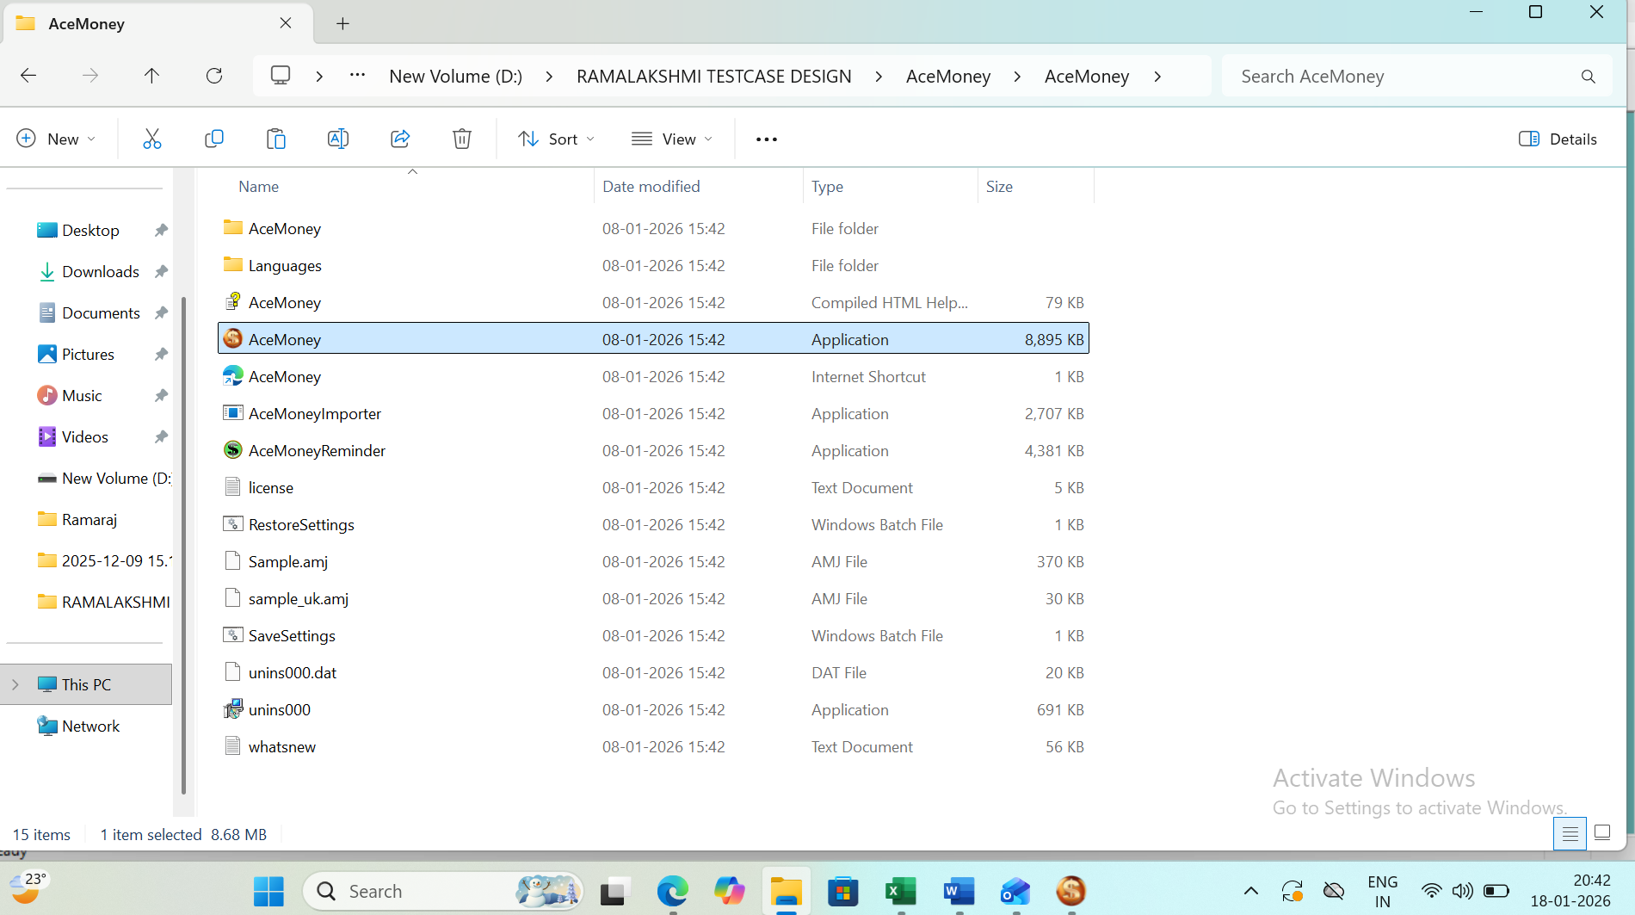
2. Account Module to click the New Account field to Enter Name Field to type the Name its ok. Accepted But,
3. Account Module to click the New Account Field to Name Field to type the text alphabets.Its also accepted this field but Getting Result is Two Different.So Raise the BugId.
4.Create the bug->For you (+) Create
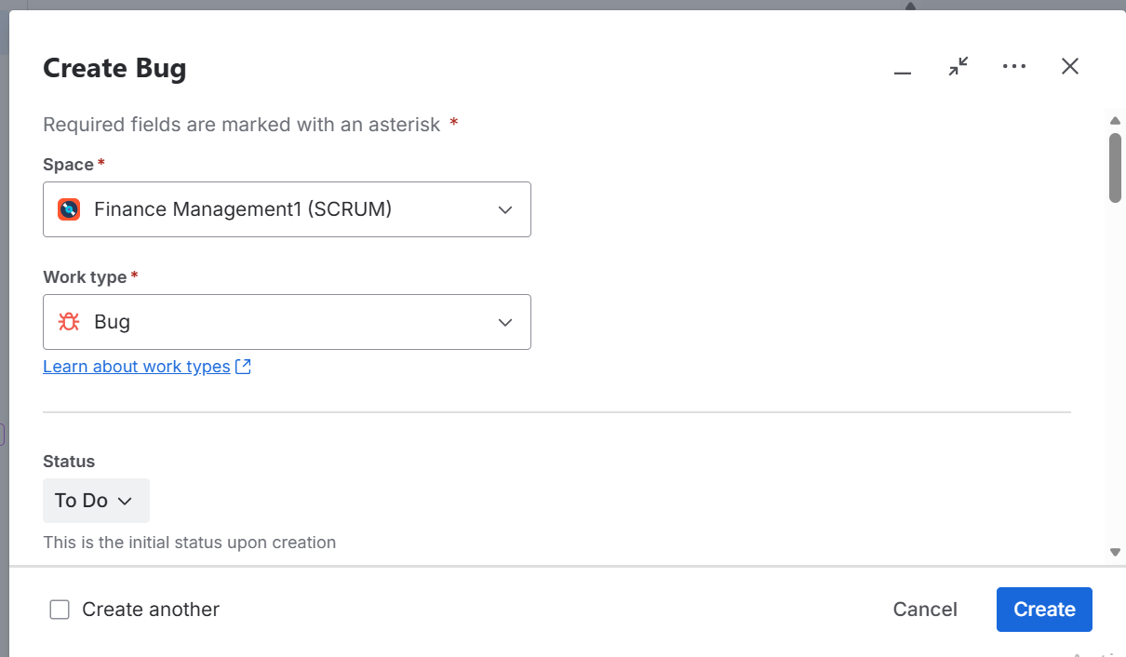
5.To view the BUG
For You Worked On Raise the”BUG ID” RedColour “TORTOISE” Symbol.

JAVA FILE OPEN
